

**Growing Your Business in the Global Economy: Not all Doom and Gloom**

Speech given by

Kristin Forbes, External MPC member, Bank of England

Brighton Summit 2015, Brighton Friday 16 October 2015

Thanks to Theresa Löber and Tsveti Nenova for playing key roles in putting together the analysis discussed in these comments. Further thanks to Abigail Whiting for her input and assistance and to James Bell, Stephen Collins, David England, Georgia Latsi, Jeremy Martin, Emma Sinclair and James Smith for helpful comments and suggestions. The views expressed here are my own and do not necessarily reflect those of the Bank of England or other members of the Monetary Policy Committee

“Doom and Gloom” seems to pervade any discussion of emerging markets these days. Ever since China’s stock market gyrations and currency adjustment sparked a swoon in equity markets around the world, newspaper headlines on the global economy have been dominated by pessimism (Figure 1). Major emerging markets, such as Brazil and Russia, are expected not just to experience slower growth this year – but suffer outright contractions. Sharp declines in global commodity prices have caused share prices of companies in this sector to plummet. Global trade (as a share of global GDP) has basically stopped growing over the past 4 years (Figure 2). At its annual meeting last weekend, the IMF downgraded its global growth forecasts – again. This is the eighth fall annual meeting in a row that they have had to revise down their forecasts for global growth in the current year. The global economy is unlikely to grow at anywhere close to the 5.7% rate at which it peaked in 2007. There seems to be an abundance of bad news to justify doom and gloom about the global economy.

**Figure 1: UK newspaper headlines about recent volatility in emerging markets**

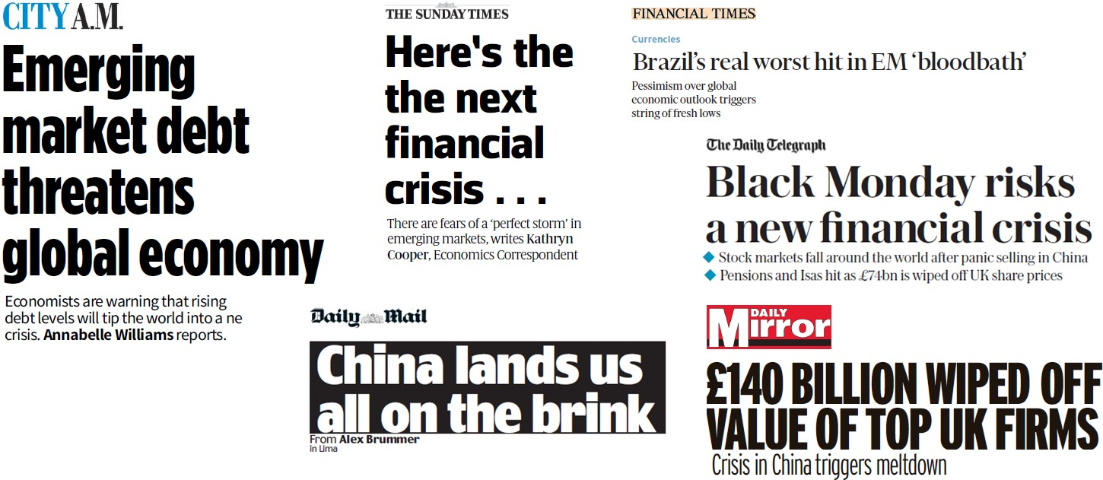

I will argue today, however, that although the risks and uncertainties in the global economy have increased, the widespread pessimism is overstated. Even though a number of emerging markets will have disappointing growth this year, and some are at risk for some type of financial crisis, there are still substantial benefits and opportunities for businesses to expand around the world – including in many emerging markets. Much of the negative news that dominates headlines today should prove temporary. Much of the doom and gloom about some countries is overshadowing healthy developments and beneficial transitions that are occurring in others. Businesses hoping to grow and expand – especially over the long term – should be looking not only inside the United Kingdom, but also outside its borders. Some of the greatest opportunities will be in many of the countries often classified as “emerging” – basically countries whose financial markets

and institutions were not as developed as the “advanced economies” in the 1980s when the term first became widely used.1

|  |  |
| --- | --- |
| **Figure 2: World trade to GDP ratio**    Source: IMF *World Economic Outlook*, October 2015 and own calculations.  Note: Based on market exchange rate weighted measures of trade and GDP. | Today I will discuss four points. First, much of the current doom and gloom about emerging markets needs to be put in context of the historic swings in commodity cycles, albeit a cycle amplified by China’s recent evolution. Second, some of the recent negative headlines merit a closer look, and after considering the actual data and differences across countries, the actual news for this group is much more balanced (albeit not all bright). Third, although there are a number of valid questions about how a UK company can profit by expanding into emerging markets, many of these concerns are overstated  and risk overshadowing substantial opportunities |

that exist today. Examples from a range of UK companies that have been successful in the emerging world highlights the types of opportunities for others. Finally, UK companies – as a whole – have been slow to expand into emerging markets. This may provide some stability over the next few months if the heightened risks in some of these countries become reality. But when viewed over a longer perspective, this limited exposure to emerging markets has caused the UK to miss out on growth opportunities in the past. If it continues, the UK could miss out on substantial opportunities in the future. Greater engagement with emerging markets might not only clarify that the grey clouds currently hanging over this region are not that dense, but may even provide some rays of much-needed sunshine.

# Doom and Gloom – or the Usual Cycle – for Emerging Economies

Despite optimistic hopes of a “great moderation” and end to the business cycle2, countries will continue to experience periods of expansion and contraction when growth rates fluctuate around longer term trends. Emerging markets will also undoubtedly continue to experience greater fluctuations than advanced economies. They tend to have weaker automatic stabilizers (such as through fiscal transfers), be more vulnerable to shifts in capital flows related to changes in the global environment, and output is more tightly linked to commodity prices, which fluctuate substantially over time. Figure 3 shows this greater vulnerability of emerging markets to commodity prices. An index of commodity prices is in red, with growth in blue for advanced economies in Figure 3a and for emerging economies in Figure 3b. Growth rates in advanced

1 It is generally agreed that this term is out-of-date. Many countries classified as “emerging” have since developed to have economies and markets that are wealthier, larger, and more sophisticated than in some “advanced economies”. At the same time, some “advanced economies” have failed to progress, and might be deemed “emerging” based on an updated classification. Unfortunately, no alternative term has caught on to describe countries in their various stages of development. For these comments, I will use the term “emerging markets” loosely, referring to the set of countries generally included in emerging market indices for investment purposes.

2 See Bernanke (2004), Stock and Watson (2002) and the IMF WEO October 2007, Chapter 5.

economies move up and down – but show little relationship to changes in commodity prices. In contrast, growth rates in emerging economies move tightly with changes in commodity prices (with a correlation of 64%, as compared to only 36% for advanced economies).

|  |  |
| --- | --- |
| **Figure 3a: Annual growth in advanced**  **economies and commodity price changes** | **Figure 3b: Annual growth in emerging market**  **economies and commodity price changes** |

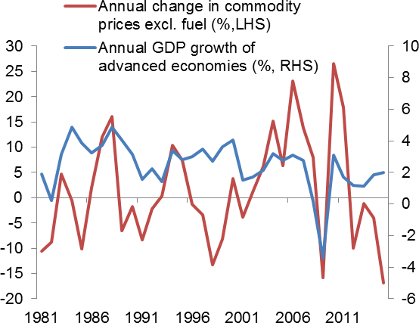 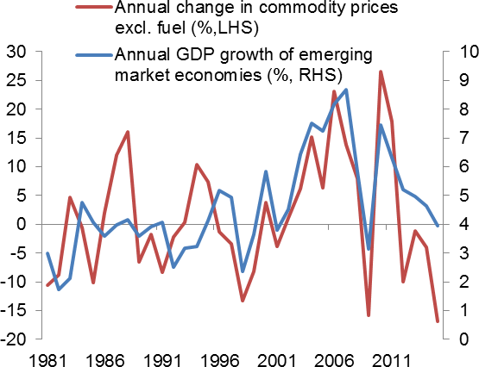

Source: IMF *World Economic Outlook*, October 2015.

Jeffrey Frankel, a professor at Harvard University, has a different explanation for these boom and bust cycles in emerging markets – that they follow the 15-year pattern established in the Bible3. Just as Joseph predicted “seven years of plenty” followed by “seven years of famine” in ancient Egypt (linked to the Nile’s flooding), Frankel speculates that emerging markets tend to experience similarly timed cycles of “feast”

and “famine” in capital flows. His 15-year cycle does a surprisingly good job at timing many of the booms and crises experienced by emerging markets since the 1970s (although his most recent forecasts predicted the latest “bust” would start around 2012). In a more serious moment, Frankel speculates that the 15-year cycle may be driven by the average time for an investor or loan officer to move off his job – leaving less experienced traders to start another boom and bust cycle…

On an equally light-hearted note, flipping through the covers of the *Economist* magazine suggests we may just continually transition

# Figure 4: Doom and Gloom covers from the

***Economist***

|  |  |
| --- | --- |
| *20 September 2008* | *4 April 2008* |

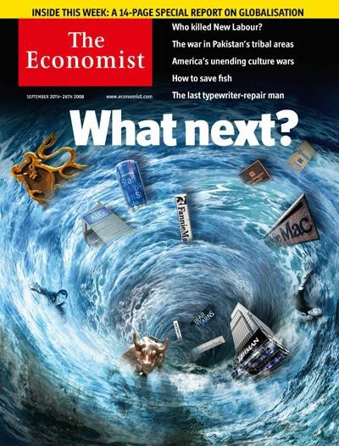 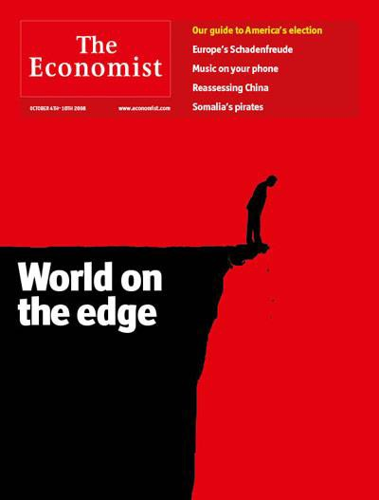

Source: *The Economist*.

3 Frankel (2012).

from phases of extreme optimism to extreme pessimism. I’ve always found *Economist* covers to be an excellent representation of the prevailing sentiment – plus being creative and humorous. Let me show you a sample of their covers from the last few years. In the fall of 2008 – the peak of the global financial crisis – there was no shortage of covers capturing the doom, gloom, chaos, and despair (Figure 4). But within less than a year – the summer of 2009 – the mood was already reversing quickly. Covers regularly began to reflect optimism about the recovery – especially in major emerging markets (Figure 5). Even Africa and Japan – areas not generally subject to positive sentiment about their economic potential – were featured in optimistic covers (Figure 6).

**Figure 5: Positive covers from the *Economist***

|  |  |  |
| --- | --- | --- |
| *15 Aug 2009* | *12 Nov 2009* | *24 Nov 2012* |

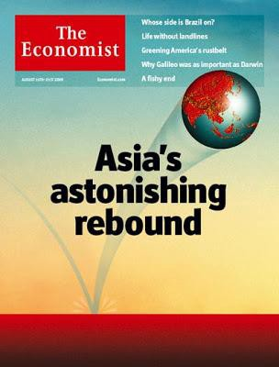 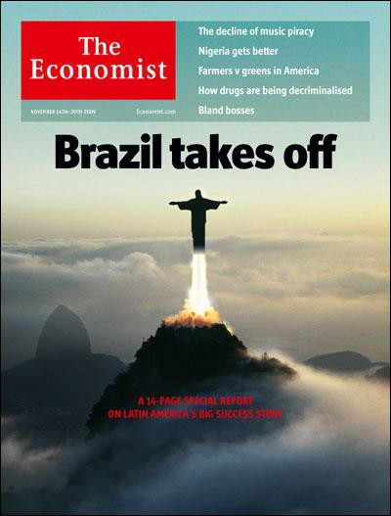 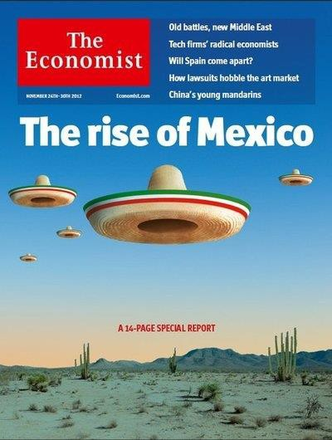

Source: *The Economist*.

# Figure 6: More positive covers from the *Economist*

|  |  |
| --- | --- |
| *3 Dec 2011* | *18 May 2013* |

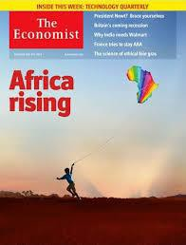 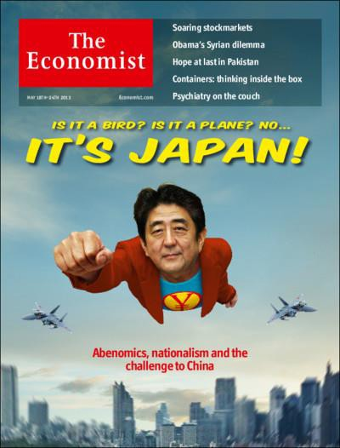

Source: *The Economist*.

|  |  |
| --- | --- |
| **Figure 7: The Great Fall of China**  *27 Aug 2015*    Source: *The Economist.* | Recently, the mood has shifted back again. Sparked by volatility in equity markets and increased risks to growth in China, concerns about emerging markets are now widespread.4 China’s great rise is now China’s “Great Fall”. (Figure 7). Just as rapid growth in China was an important support for commodity prices and thereby commodity exporters, slower growth in China is now an important factor driving falls in commodity prices and vulnerability in commodity exporters.  Emerging economies which did not take advantage of the boom years to strengthen their fiscal positions and build strong institutions will face challenges – in some cases severe challenges. As the old saying goes, it is only when the tide goes out that you see the rocks. (Or Warren Buffet’s variant: “It is only when the tide goes  out that you see who has been swimming naked.”) |

Brazil shows this combination of challenges. It did not take advantage of the commodity boom and easy access to capital after the crisis to build buffers and undergo needed reforms. As a result, its hoped-for lift off has been aborted (Figure 8). Hopefully the UK recovery will not weaken so that the *Economist* produces a cover showing Big Ben and the houses of Parliament in a similar nose dive.

4 For a more detailed discussion of this recent increase in risks to emerging markets, see Haldane (2015).

# Figure 8: Brazil covers

|  |  |
| --- | --- |
| *12 Nov 2009* | *28 Sep 2013* |

 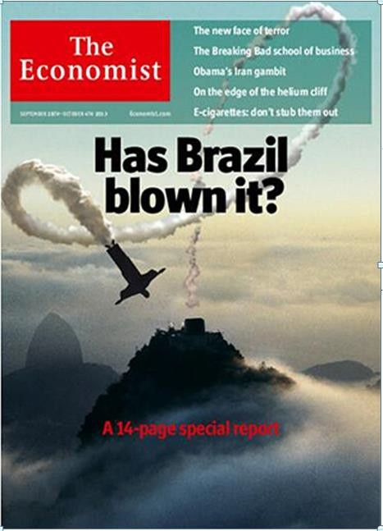

Source: *The Economist.*

The data on emerging markets backs up this shift of sentiment captured by the *Economist* covers. Figure 9a shows growth forecasts for emerging markets (in red) and advanced economies (in blue) made in 2010.

Emerging markets were expected to bounce back from the crisis and return to average annual growth of about 7% from 2010 through 2015. This would be a return to their average annual growth rate from 2002 through 2008 – which was in turn the fastest growth rate recorded in emerging markets for a window of this length since the IMF started tracking this country group in 1980. Advanced economies were also expected to recover, albeit to a less glamorous growth rate of about 2.5%.

Unfortunately, Figure 9b shows what actually happened. These forecasts proved too optimistic – especially for emerging markets.5 Annual growth has been below these 2010 forecasts for every year since 2011 – for both developed economies and emerging markets. The latest IMF forecasts – released last week – suggest that growth in the advanced economies is finally above where it was in 2011. In contrast, growth in emerging markets may be as much as 2.7 percentage points below that forecast five years ago.

5 It is worth noting that emerging market growth forecasts tend to go through periods of regularly having positive or negative prediction errors. For example, in contrast to recent experience, forecasts consistently under-predicted strong growth before the crisis.

# Figure 9: IMF forecasts for advanced and emerging economies from 2010 and 2015

|  |  |
| --- | --- |
| *a) IMF forecast in 2010…* | *b) …and outturn and new forecast.* |

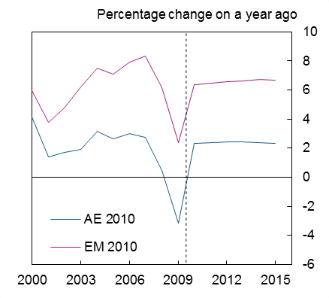Percentage change on a year ago

10

AE 2010

EM 2010

AE 2015

EM 2015

8

6

4

2

0

-2

-4

-6

2000 2003 2006 2009 2012 2015

Source: IMF *World Economic Outlooks*, October 2010 and October 2015.

# Take a Closer Look

It is tempting to look at figures such as these and conclude that there is little potential in emerging markets. Recently forecasts have been too optimistic. Even seeds of promise will never have long enough to grow into vibrant plants. As a business, it might be better to avoid the volatility and uncertainty.

But this would be an inaccurate reading of the data. Emerging markets are subject to substantial volatility and uncertainty, and earlier forecasts were too optimistic. But there can still be substantial opportunities. Let me return to the hard data to make this point (even if not quite as entertaining as the *Economist* covers).

To begin, let’s put these recent growth disappointments in emerging markets in context. Figure 10a shows the IMF’s one-year-ahead forecasts for growth in China and in all emerging markets from 2012 through 2016. They show the continual downward revisions in what we have expected from these countries. Now I’ll put these same graphs on a figure with the same one-year-ahead forecasts for the UK, euro area, US, and advanced economies as a group (Figure 10b). Even though growth in the advanced economies has recently stabilized, it is still substantially lower than in China and other emerging markets as a group. The downgraded growth rate expected for emerging markets in 2015 that has garnered such negative headlines is still likely to be around twice as fast as in advanced economies.

# Figure 10a: Vintages of IMF WEO one-year ahead forecasts for China and Emerging markets

2012 2013 2014 2015 2016

10

9

8

7

6

5

4

3

2

1

0

# Figure 10b: Vintages of IMF WEO one-year ahead forecasts for selected regions and countries

2012 2013 2014 2015 2016

10

9

8

7

6

5

4

3

2

1

0

China Emerging

UK Euro

United China Advanced

Emerging

economies

area

States

economies economies

Sources: IMF *World Economic Outlook*s, October 2011 to October 2015.

Sources: IMF *World Economic Outlook*s, October 2011 to October 2015.

The fact that slower growth in emerging markets does not appear quite as dismal when compared to the other regions is also important when considering the drivers of overall global growth. Where has global growth in the world recently come from? Where will global growth come from in the future? Figure 11 shows PPP-weighted global growth (the black line) since 1990, and how much of this growth was driven by different countries and regions. Since September 2000, over half of global growth has been driven by emerging economies. Even in 2015 – when advanced economies will be growing at their fastest rate and emerging economies at their slowest since the crisis – emerging economies are expected to drive almost

|  |  |
| --- | --- |
| **Figure 11: Contributions of regions and countries to global growth**  US Percentage change on  EA previous year  Other AEs  China 7  Other EMEs 6  PPP-wtd world  5  4  3  2  1  0  -1  -2  -3  1990 1993 1996 1999 2002 2005 2008 2011 2014  Source: IMF *World Economic Outlook*, October 2015. | three-quarters of global growth.6 Just one country – China – has been responsible for over one-third of global GDP growth since 2011, and even after incorporating its recent slowing, is still expected to drive about 35% of global growth this year. Any business looking at growth opportunities should be considering these regions that are responsible – by far – for the biggest contributions to global growth.  Another important consideration to factor in when evaluating the gloomy headlines about recent trends in emerging markets is that there are substantial differences across countries in this group. Yes – many emerging markets are facing challenges from slower growth in key export markets (such as China) and from weaker prices for commodity exports. But some economies are  commodity importers and are |

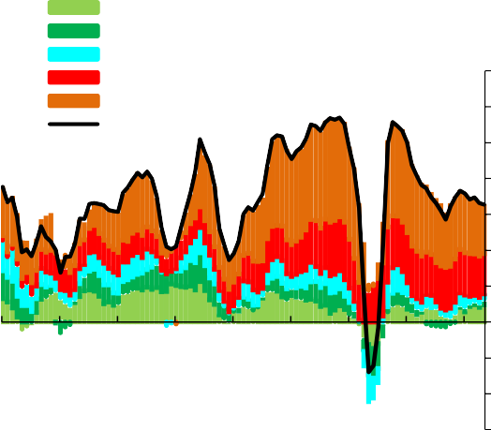benefiting from the sharp falls in commodity prices. Others took advantage of strong export growth and high commodity prices in the past to build reserves and pay down debt – so that they have sound financial positions to adapt to recent developments. Many emerging markets have adopted policies that will make them more resilient to shifts in the global economy – such as more flexible exchange rates, better regulation of their financial systems, and improved institutions to attract investment. Other emerging markets, however, have not been as foresighted. Unfortunately, it is some of these economies that are currently exerting an inordinate amount of influence and weighing on statistics for emerging markets as a whole.

An example of this is Figure 12a. It shows a swathe of growth rates for emerging economies – representing in each year the fastest growing economy, the slowest, and everything between. The swathe has shifted down sharply – and could be interpreted as showing a widespread and dramatic slowing in emerging markets. But the problem with these types of swathes is that they can be heavily influenced by a single outlier. A closer look at this one suggests that much of the dramatic shift down is explained by just one country – Ukraine. If you drop Ukraine from the graph, as in Figure 12b, there is still some general slowing – especially amongst the fastest growing economies – but not nearly as dramatic.

An even closer look at the underlying data suggests that five countries account for much of the extreme weakness in emerging markets this year. Ukraine, Russia, Brazil, Belarus, and Ecuador are the only emerging markets that are in recession (defined as two quarters of negative quarterly GDP growth).

6 Granted, when global growth is calculated based on GDP measured using market exchange rates instead of PPP, the recent contribution of emerging markets to global growth is lower. But even using this measure, emerging markets have, on average, driven around 70% of global growth in 2010-2015.

Figure 12c shows their sharp deterioration in economic performance over the past few years. Although the global trends affecting emerging economies more broadly are weighing on each of these countries, a far more important factor behind their weakness is domestic developments. The biggest challenges facing these countries are hardly representative of the challenges facing all emerging markets.

# Figure 12: Recent growth in emerging markets

|  |  |
| --- | --- |
| *a) YOY growth rate swathe of EMs (xNIAE*)* | *b) YOY growth rate swathe of EMs excluding*  *Ukraine (xNIAE*)* |

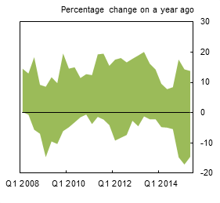 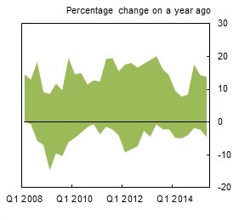

* Newly industrialized Asian economies.

|  |  |
| --- | --- |
| *c) EMEs currently in recession\**  cid:image001.png@01D10647.0956E770  Note: This chart plots year-on-year GDP growth rather than quarter-on-quarter, which is the measure relevant for recession timing.  Source: Thompson Reuters Datastream. | A closer look at some of the individual emerging markets also presents a more nuanced picture. The IMF recently upgraded its growth forecast for emerging and developing Europe in 2015 and 2016 (albeit only by 0.1% each year).7 It still expects India – the 2nd largest emerging economy  – to grow by 7.3% this year and 7.5% next year.  The actual data from China – where much of the negative sentiment on the emerging world originated – has not yet weakened by anything close to what the gloomy headlines imply. For example, the IMF recently kept its growth forecasts for China steady at 6.8% for 2015 and 6.3% in 2016. The Bank of England – which had  previously been more negative about China’s |

7 See the IMF’s latest forecasts in the *World Economic Outlook* released in October 2015 at: [http://www.imf.org/external/pubs/ft/weo/2015/02/index.htm.](http://www.imf.org/external/pubs/ft/weo/2015/02/index.htm)

growth prospects than most forecasters – may even need to revise up their forecasts for 2015. There is no doubt that growth in China is slowing from its unsustainable rates from the past few years. There is also no doubt that it will continue to face substantial challenges related to its debt overhang, financial system, and demographics. But the Chinese government has also shown its commitment to using its existing policy options to support growth. Just as important, many growth measures (including many alternative indicators created to see past problems with China’s official data) tend to better capture activity in manufacturing and investment, but may not fully capture a healthy shift towards services and the consumer sector. There is no doubt that the manufacturing sector is slowing, but recent analysis by JP Morgan suggests that the service sector may be picking up by so much that it largely compensates for weakness in manufacturing to support overall growth.8 If true, this would be part of a healthy structural shift in the Chinese economy to a more sustainable growth path in the future.

Looking even more broadly, this relative stability in China, is shared by many emerging markets that are not commodity exporters. This is apparent in Figure 13, which graphs growth rates for commodity exporters on the left, and other emerging markets and developing economies on the right. Actual growth rates (blue bars) have been lower than forecast (red dots) for each set of countries, but growth in commodity exporters has fallen much more sharply over the past four years. Growth in non-commodity emerging and developing economies has been more stable, and in 2015 is expected to be around the same level as in 2012. This resilience is noteworthy and highlights the importance of differentiating between the risks in different emerging markets.

# Really? Where are the Opportunities?

I’m sure that many of you are still sceptical. Even if emerging markets are likely to continue to be the major source of global growth in the future, and even if the situation in many emerging markets is not as dire as the headlines imply, are there really opportunities? And whether or not this is just another round in the usual cycle of boom and bust in emerging markets – how can your company benefit from this?

There are a number of reasons you should be sceptical. Even if emerging economies are growing faster than advanced economies on average, if they are growing from a small base, this does not necessarily translate into a large market for business. As every company knows, it is often easier to put up stellar growth rates when starting from almost nothing, than to sustain those stellar rates when you are larger. And the economic size of many emerging markets is still small compared to that of many advanced economies.

Figure 14 makes this point. Don’t worry, even though I am not European, I realize that the labels on the

8 More specifically, their analysis shows that growth in the service sector has accelerated from 6.1% in Q1 (quarter over quarter, seasonally adjusted) to 9.6% in Q2 based on a number of statistics. They claim that this is supporting GDP growth close to the headline rate reported in the official figures, rather than at the much lower rate implied by the slowdown implied by statistics that place more weight on manufacturing. They caution, however, that some of the growth in services may reflect unsustainable growth in the financial sector. See JP Morgan, *Global Data Watch: China’s Two-Speed Economy,* October 9, 2015.

countries are not accurate. I have purposely written the name of emerging markets inside the borders of European countries which have a comparable economic size.9

|  |
| --- |
| **Figure 13:**  **Average Growth in Commodity-Exporting versus Other Emerging Market and Developing Economies, 1990-2015** *(Percent)* |
|  |

Source: Figure 2.2. from IMF *World Economic Outlook*, October 2015, Chapter 2.

9 Size is measured based on 2014 GDP in US$ based on IMF data.

# Figure 14: Map of Europe with countries replaced by emerging markets with comparable GDP

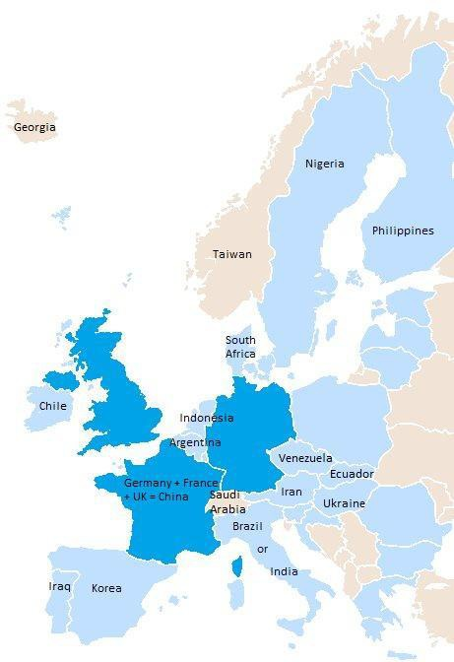

Note: Based on annual GDP data for 2014, converted into US dollars using market exchange rates.

**Source: IMF *World Economic Outlook*, October 2015.**

This map helps put the size of many of the star emerging markets in context. For example, India and Brazil – the two largest emerging markets after China – each have economies that are currently about the same size as that of Italy. South Korea and Indonesia – two of the more promising markets in East Asia – are respectively the size of Spain and the Netherlands. The largest African markets – South Africa and Nigeria – are respectively the size of Denmark and Sweden. Major oil economies that generate so much attention geopolitically are less intimidating when judged in this context; Saudi Arabia produces the annual output of Switzerland, Iran that of Austria, Iraq that of Portugal, and Venezuela that of the Czech Republic. Even after a number of years of stronger growth than in the advanced economies, the annual production of many emerging markets is still only on par with individual countries within Europe. But on the other hand, the GDP of all of Europe is comparable to that of just a subset of emerging markets. The GDP of the three largest economies in the EU – Germany, the UK and France (the 4th, 5th and 6th largest economies in the world) – is equivalent to that of just one emerging market – China. These are clearly substantial markets.

An even more compelling reason why businesses should consider the opportunities in emerging markets is the relative size their economies are likely to be in the future. A number of different public and private sector forecasters make long-run predictions of how economic heft could be distributed around the world in several decades, based primarily on slow moving trends such as demographics. Any long-term forecasts such as these obviously require a number of heroic assumptions, especially for emerging economies with substantial uncertainty about the stability of their economies and institutions. Nonetheless, I find these types of exercises helpful when thinking about likely future scenarios.

What is striking about these scenarios – done using a range of assumptions and techniques – is that they all tend to reach the same general conclusion; emerging markets are likely to play an increasingly important – and possibly dominant role – in terms of global economic heft. For example, Figure 15 shows one of these forecasts done by HSBC.10 It shows how advanced economies used to be the key drivers of global growth, but emerging markets took over the baton this decade. Going forward, emerging markets are expected to drive a larger and larger share of global growth. PwC has done the most recent analysis which I could find of these types of trends, and predicts that this shift will generate major changes in the global economic order. It projects that in 2050 China and India will be the two largest economies in the world, with Indonesia, Brazil and Mexico in 4th, 5th, and 6th place respectively (Figure 16).11 Their underlying growth assumptions do not seem overly optimistic; for example, they predict growth in China will slow sharply to about 3 ½% from

2021-2030 and then about 2 ½% through 2050. The US is predicted to be the only country currently classified as advanced in this top tier. The UK will be one of the remaining developed economies in the top- 15, predicted to hold a respectable 11th place position.

Even if these long-term forecasts play out, another reason for scepticism about the prospects for business in emerging markets is that even if an economy is large when measured by total production, it may not have a large number of viable customers. According to UN estimates, Russia’s population has already declined by

10 HSBC Global Research, *The World in 2050: From the Top 30 to the Top 100.* January 2012.

11 PwC, *The World in 2050: Will the Shift in Global Economic Power Continue,* February 2015. Projections based on GDP adjusted for PPP in 2014 US$bn.

2% since 2000 and is expected to continue to contract going forward. China’s population is expected to begin to decline in 2029. High birth rates in much of the emerging world have been dropping sharply.

# Figure 15: Contributions to HSBC projections of global growth from advanced and emerging economies

Source: HSBC Global Research, *The World in 2050: From the Top 30 to the Top 100.* January 2012..

**Figure 16: Table of PwC rankings for 15 largest economies in 2014 and predicted in 2050**

|  |  |  |  |  |
| --- | --- | --- | --- | --- |
|  | **2014** |  | **2050** | |
| **PPP rank** | **Country** | **GDP at PPP (2014 US$**  **billion)** | **Country** | **Projected GDP at PPP (2014 US$**  **billion)** |
| 1 | China | 17,632 | China | 61,079 |
| 2 | United States | 17,416 | India | 42,205 |
| 3 | India | 7,277 | United States | 41,384 |
| 4 | Japan | 4,788 | Indonesia | 12,210 |
| 5 | Germany | 3,621 | Brazil | 9,164 |
| 6 | Russia | 3,559 | Mexico | 8,014 |
| 7 | Brazil | 3,073 | Japan | 7,914 |
| 8 | France | 2,587 | Russia | 7,575 |
| 9 | Indonesia | 2,554 | Nigeria | 7,345 |
| 10 | United Kingdom | 2,435 | Germany | 6,338 |
| 11 | Mexico | 2,143 | United Kingdom | 5,744 |
| 12 | Italy | 2,066 | Saudi Arabia | 5,488 |
| 13 | South Korea | 1,790 | France | 5,207 |
| 14 | Saudi Arabia | 1,652 | Turkey | 5,102 |
| 15 | Canada | 1,579 | Pakistan | 4,253 |

Source: Price Waterhouse Coopers “The World in 2050”, February 2015.

It is true that population growth around the world – in advanced economies as well as emerging markets – is slowing. And in some countries – such as Russia – it is slowing more sharply than in others. But populations in most emerging markets will undoubtedly continue to expand at a substantially greater rate than in advanced economies. As a result, they will be the source of the fastest growth in potential customers, as well as an increasing share of potential customers around the world. For example, Figure 17a shows the continents as traditionally drawn based on land mass; Figure 17b then distorts the continents to reflect their size based on their current population. This shows the large populations that currently exist in Asia and Africa. Granted – some emerging markets with large populations today will become less important in the future (such as China and Russia) – but many others will have an impressive number of potential customers – and far more than in the advanced economies.

But – of course a large population does not translate into a large market for most products if the country is poor and people have little income to spend. This is true today in some emerging markets – even in many that have received attention for strong growth performance. Figure 18 shows that average income levels in most emerging markets are substantially lower than in advanced economies (with darker maroon shading denoting lower incomes and darker blue denoting higher incomes). Income levels in many of the larger emerging markets discussed earlier are a fraction of those in the advanced economies. A large proportion of the 1.3 billion people living in India are not shopping online, or even in traditional stores. They are just trying to survive with the most basic food and shelter – and often not even that.

# Figure 17a: Map of the world scaled by area of each continent

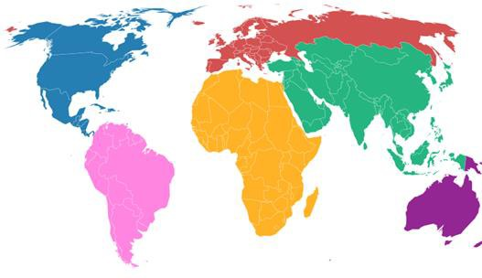

Source: [http://www.carbonmap.org](http://www.carbonmap.org/)

# Figure 17b: Map of the world scaled by population of each continent as of 2013

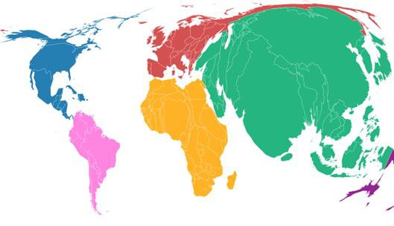

Source: [http://www.carbonmap.org](http://www.carbonmap.org/)

# Figure 18: Map of the world coloured based on each country’s GDP per capita*

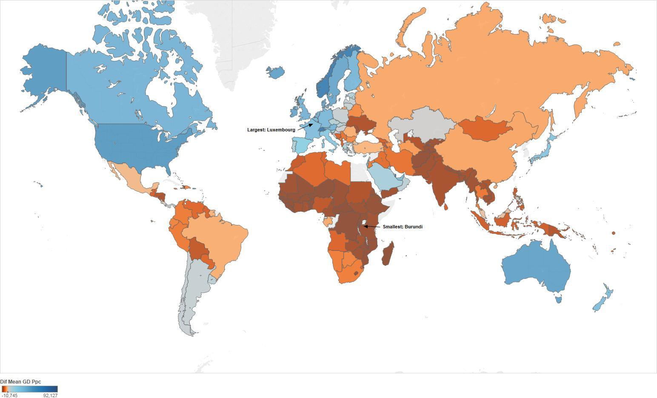

Source: IMF *World Economic Outlook*, October 2015 and own calculations.

* Based on 2015 GDP estimates in terms of US dollars at market exchange rates from the IMF *World Economic Outlook,* October 2015. GDP per capita is plotted in terms of US dollar deviation from the world average. The darker blue countries are those whose GDP per person exceeds the world average by most and conversely, the countries coloured in darkest maroon have lowest GDP per capita.

This concern that large populations and large economies do not necessarily translate into a large number of potential customers is certainly valid. Some of the promise in emerging markets is only beginning to occur as average income levels increase enough to graduate people out of dire poverty and into the middle class. The number of people in these countries who are beginning to have discretionary income to spend on items other than the most basic food, shelter and clothing, however, is growing rapidly. Figure 19 shows OECD predictions of where middle-class consumption currently is coming from – and how this is likely to evolve in the future.12 The US, EU and Japan currently dominate middle class consumption, but this share is quickly being eroded by growth in the middle class in the emerging world – especially in China, India, and other Asian countries (excluding Japan). This is a remarkable growth in a pool of potential customers.

# Figure 19: Share of middle-class in global consumption, 2000-2050 (percent)

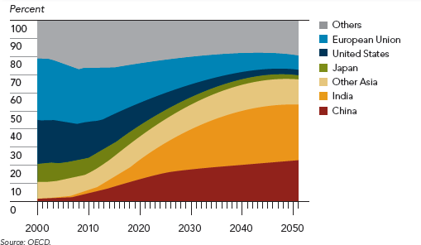

Source: Kharas (2010).

Vodafone is an example of a UK company that identified these population trends and has been able to adapt its products to take advantage of this growing customer base in emerging markets – including in some of the poorest. Vodafone currently has 400 million customers around the world. It could never have reached this number if it had remained only in the UK – even if it found a way to sell five phone subscriptions to every single man, woman and child (including infants) in the UK’s population of 65 million. Part of Vodafone’s success in reaching so many customers, including in some low-income countries, was helping establish money transfer systems via phone for individuals that do not have traditional bank accounts. As a result of this willingness to adapt and expand abroad, emerging markets in Asia and Africa now generate about

12 “Middle class” is defined here as those households with daily expenditures between $10 and $100 per person in PPP terms (Kharas, 2010).

one-third of Vodafone’s revenue.13

Some companies may have a harder time adapting their products to lower income customers. But there could still be a range of other profitable ways to engage with emerging economies. Once again, the differences across the varied economies that constitute “emerging” are important. Average income levels in some emerging economies are similar to in some advanced economies, such as Kuwait (with per capita income of about $30,000 in 2015US$) which is comparable to that of Italy, and South Korea (around

$27,000) comparable to that of Spain.14 Preferences and tastes may vary, but the differences are unlikely to be greater than across different advanced economies, such as Japan relative to Canada. Other emerging economies with low average incomes could still yield large numbers of potential customers if they have large populations. For example, India’s average income per person will still be under $1700 in 2015, so that most of its population probably cannot afford your products. But if only 1% of India’s current population of 1.3 billion has enough disposable income to buy what you make – that is still 13 million customers. If you could eventually reach 10% of India’s population, that is 130 million customers!

Work by Abhijit Banerjee and Esther Duflo, two professors at MIT, provides insights on the priorities and types of items that people chose to buy as their incomes increase and they graduate through different layers of the middle class.15 They find that priorities include: entertainment, health care, domestic infrastructure, and better quality food and drink (albeit not necessarily more). An example of a company that is benefiting from these trends is Diageo. Although cheap alcohol is available virtually anywhere in the world (at least where it is not forbidden for religious reasons), higher quality spirits is a perennial favourite as income levels rise.

This is true not just as people graduate out of poverty, but also as they move to the upper-middle class and then the wealthy. Diageo currently operates in 180 countries, with 43% of its business in emerging markets in Latin America, Asia, Africa, Eastern Europe and Turkey.16 Just Africa – a continent with some of the most dire poverty in the world and not on many company’s lists of promising opportunities – constituted 10% of Diageo’s profits over the year ending in June 2015.

A final reason for scepticism about the prospects for a UK company in emerging markets is that, even if there was a large enough pool of customers with sufficient income to purchase your products, it would be extremely difficult to compete with goods produced locally. Many types of goods that are produced locally – especially if they have a large labour component – would likely be cheaper due to the lower labour costs in most emerging markets. Local companies might also be more adept at reflecting local tastes and preferences, and local companies would not have to pay to transport an item produced abroad. These are valid hurdles for some sectors and items – especially items that are costly to transport or made using a high share of low-skilled labour. But for other products, UK firms can not only compete – but fill important niches that are unlikely to be satisfied by domestic companies.

13 See Vodafone’s Annual Report for 2015.

14 It is worth noting that South Korea has now graduated from being on some lists of emerging markets.

15 For example, see Banerjee and Duflo (2007).

16 <http://www.diageo.com/en-us/ourbusiness/ourregions/pages/default.aspx>

One example is brands that are known for their high quality. UK companies with respected names will be in demand, especially in emerging markets where locally-produced items have less certain quality and less prestige. This is true not only for companies such as Diageo (as discussed above), but especially for fashion labels such as Burberry. The iconic trench coats and scarves are sought after around the world, so that sales abroad now far exceed those in Europe. Just the Asia/Pacific region accounted for 38% of retail/wholesale revenue in 2014/2015, and this does not account for the fact that over half of mainline sales within countries such as the UK and Europe are from travelling customers – many from emerging economies.17 UK stores are even hiring sales representatives who can speak Mandarin to encourage this important source of business.18

But it is not just name brands signifying quality and prestige that UK companies can bring to emerging markets. It is also skills and expertise that have not yet been developed and honed in many emerging economies. For example, consider Arup – a UK multinational which provides engineering, design, planning, project management and consulting services for building. It has offices in 42 countries and projects in over 160 countries.19 It has played a role in building everything from rail links in South Africa, to the China Zun Tower that will soon be the tallest building in Beijing, to high-rise towers in Mexico, to the stunning performing arts centre in Taipei. Some of its most impressive projects have revolved around sporting events

– such as the Yaz hotel in Abu Dhabi (the first hotel to span a Formula One race course), Beijing’s iconic “Bird’s nest” (that hosted the 2008 Olympics) and Singapore’s award-winning sports hub. Fast growth in emerging markets has been generating – and will continue to generate – demand for large scale building projects. Young companies that do not have decades of experience with these types of major, technical projects will find it hard to compete – rather than the other way around.

In addition to providing building services, there are a number of other service industries where UK companies could fill an important niche in emerging markets – such as insurance, financial management, legal services, and accounting. These are sectors in which the UK has traditionally had expertise, which are much less well developed in emerging markets, and which are increasingly in demand as these economies develop and transition away from more manufacturing-intensive production (as discussed previously for China). These are also sectors where expertise and intellectual capital are important – expertise and skills which are more difficult to develop and build quickly than in other sectors. The UK company, Michelmores LLP, provides an interesting example of how creative thinking in these sectors can yield opportunities.

Michelmores is a historic law firm – founded in Exeter in 1887 – the year of Queen Victoria’s Golden Jubilee. It has navigated through World Wars and continually adapted – most recently by increasing engagement with China. It has started a “China desk” to support the increasing number of Chinese corporations and private individuals investing abroad, as well as to support UK companies hoping to do business in China.20 Recently

17 <http://www.burberryplc.com/documents/annual_reports/annual-report-2014-15.pdf>

18 According to their 2014/15 Annual Report, “…the group continues to focus on engaging with the Chinese luxury consumer, both in

China and while travelling abroad, including: by […] investing in digital and in-store services such as Mandarin-speaking sales associates across top tourist destinations outside China”.

19 See Annual Report at <http://publications.arup.com/Publications/A/Annual_and_Corporate_Reports/Annual_Report_2014.aspx>

20 <http://www.michelmores.com/what-we-do/services/chinese-legal-services>

it launched YangTze Law – the UK’s first wholly-owned Chinese law firm. This new company will provide support for “Chinese clients in navigating their way through the UK and global business landscapes” and shows the “important global role of London as a legal hub and the attractiveness of our jurisdiction.” 21

# A Missed Opportunity?

At this point, I have hopefully made you at least consider that the outlook for business in emerging markets may not be as dire as the headlines predict. Could your product be attractive – possibly after some adaptation – to segments of the faster growing populations in emerging markets? Could you satisfy the rapidly growing demand for services as many of these economies rebalance toward greater spending in this sector? Do you have a brand whose quality and name recognition might appeal to populations with a growing middle class? Do you have any expertise or skills honed over the years that are hard to replicate in newer companies – especially for sectors which are only beginning to develop in many emerging markets?

To be fair, even if you answer affirmatively to one or more of those questions, doing business in emerging markets can still be fraught with risks. The business environment can be substantially more challenging than in the UK and other advanced economies. Sharp currency movements, more typical in emerging markets, can undermine business models.22 Institutions and sound governance can take decades to develop – so that even the most basic business requirements, such as getting permits and enforcing contracts, can be difficult. Intellectual property rights are flagrantly violated in some countries, with numerous anecdotes of local companies brazenly copying foreign products, with little fear of prosecution in impenetrable and slow legal systems. Corruption and the implicit assumption that businesses will pay bribes to get things done can be difficult to contend with. Infrastructure can be abysmal – with regular electricity outages in some countries and traffic jams that make London traffic look smooth. Pollution and environmental concerns can be substantial – generating not only longer term risks, but making some major cities in emerging markets unhealthy to live in today. In some countries, governments are less well established and lack the legitimacy of long-established democracies, increasing risks of instability, sudden regime shifts, and in the worst cases even safety concerns for local staff.

Granted, many advanced economies are not immune to many of these challenges. Consider the most recent showdown in the US Congress that could lead to a government shutdown. Or consider the irresponsible activities in financial institutions in the US and UK that contributed to the recent crisis. Anyone who has recently tried to get on the Tube in Victoria Station during rush hour – and been unable to even squeeze onto the platform – can sympathize with insufficient infrastructure. Nonetheless, these types of challenges can be magnitudes greater in some emerging markets.

Nonetheless, a number of UK companies have been able to manoeuvre through these challenges to take advantage of the rapid growth and increasing demand in emerging markets – such as the examples

21 For more information, see <http://www.michelmores.com/news-views/news/yangtze-law-launch-michelmores>

22 See Forbes (2014) for a discussion of the challenges of sharp currency movements to businesses in the UK.

discussed above. As a whole, however, UK, companies have been slower to increase their exposure to emerging markets than in most other economies. Figure 20 shows the export exposure (relative to GDP) of various countries to just China and to all emerging markets. The UK stands out for its low exposure to emerging markets – the third lowest of all the major advanced economies.

# Figure 20: Exports to China and all EMEs by country

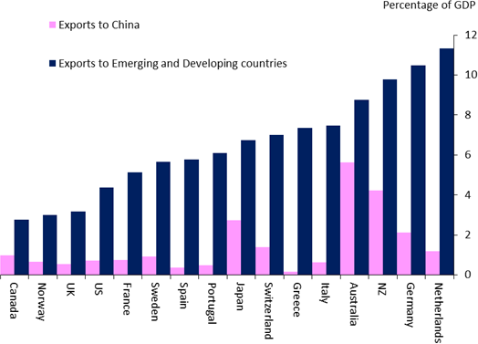

Source: IMF and own calculations.

Granted, the fact that the UK currently has less direct export exposure to emerging economies could provide some respite over the next year or so due to the heightened risks in many of these countries. In fact, if growth in the UK’s two most important trading partners (the US and euro area) continues to meet or exceed expectations for 2015, while growth in emerging economies slows moderately, the UK could be in the enviable position of facing stable growth in its export markets despite a broader slowing in the global economy.23 Of course, if some of the potential risks to emerging markets play out – such as a sharper slowdown than expected or financial crisis of some type – then the UK economy is unlikely to be immune.

But based on what has actually occurred to date, the limited direct exposure of the UK to emerging markets (even when incorporating second-round effects through other countries such as Germany), appears manageable. This is especially true when considered relative to the strength of the UK’s domestic-led expansion – which shows all signs of continuing, even if at a more moderate pace than in the earlier stages of the recovery. As a result, despite the “doom and gloom” sentiment, the news on the international economy has not caused me to adjust my prior expectations that the next move in UK interest rates will be up and that it will occur sooner rather than later.

23 In other words, it is possible that UK-weighted global growth (when countries are weighted by their share in UK exports) could be steady, while GDP- or PPP-weighted global growth (calculated the traditional way) slows.

Nonetheless, even if it provides a bit of stability this year, the UK’s relatively low exposure to faster growing regions of the world has undoubtedly contributed to the UK’s unimpressive export performance since the turn of the century. If this continues, it will also act as a drag on UK exports, and therefore growth, in the future. A more detailed look at the breakdown of UK exports in Figure 21 shows the average growth rates of different countries to which the UK exported from 2000 through 2014, with countries on the left constituting 55% of UK exports, and countries on the right only 14%. There is a stark difference in average growth rates. The countries to which the UK had much less export exposure have grown much faster. This has been a missed opportunity for UK exporters. It has also contributed to the UK’s declining share of global trade – as shown in Figure 22. Although the UK is not the only advanced economy to see its share of global exports decline, it is near the bottom of the pack.

# cid:image004.png@01D0FF87.B466D3D0Figure 21: Average country growth rates (2000 to 2014) and UK export exposure

**Figure 22: Change in share of world exports, 2000 to 2014**

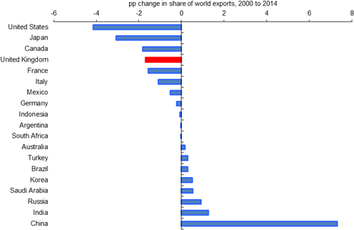

Source: IMF and own calculations.

Rough back-of-the-envelope calculations help quantify how this continued pattern of low export exposure to the faster growing economies could act as a drag on UK exports and growth in the future. For example, consider if the UK shifted its export exposure (in Figure 23a) to a pattern similar to that in the United States (in Figure 23b) – so that the 58% of UK exports now went to emerging markets instead of the 37% at

end-2014.24 More specifically, divide the £515 billion of UK exports in 2014 between emerging markets, North America, European Union, and other advanced economies based on these US and UK export shares. Then assume that these 2014 exports to each region grow through 2020 at the average growth rate forecast for each region (according to the IMF’s latest forecast for 2015-2016). These assumptions build in the recent strength in advanced economies and slowdown in emerging markets, and should therefore be a conservative estimate. The original export shares, resulting exports to each region, and exports to the world as a whole under each scenario in 2020 are reported in Figure 24. Exports in 2020 would be £23 billion larger if the UK had greater exposure to emerging markets as found in the US. Or, as a more optimistic scenario, assume that emerging market growth recovers to its average rate over the last 10 years (thereby averaging 6.2% through 2020 instead of 4.3%). In this scenario, UK exports would be £39 billion larger at the end of 2020. If import shares were not affected, either of these scenarios would imply a noteworthy reduction in the UK deficit in trade and services (which was £35 billion in 2014). In other words, increasing UK exposure to emerging markets to shares similar to the US could reduce the UK deficit in trade and services by somewhere between 2/3 to wiping it out completely and generating a surplus!

24 It is worth noting, however, that the UK share of exports to emerging markets is similar to that for other major European countries, such as France and Germany. This may reflect the more rapid increase in trade within the European Union that means a slower growth in the share of trade to outside this region.

# Figure 23: Geographical breakdown of exports in 2014

|  |  |
| --- | --- |
| **a) UK** | **b) US**  North America |

North America

€A €A

Other European Advanced Japan

Other European Advanced Japan

Pacific Pacific

South East Asia South East Asia

CEE & Central Asia CEE & Central Asia

Middle East & North Africa

Sub-saharan Africa

Middle East & North Africa

Sub-saharan Africa

Latin America & Caribbean

Latin America & Caribbean

Source: World Bank and own calculations.

# Figure 24: UK Export Scenario with Increased Exposure to Emerging Markets

|  |  |  |  |  |  |  |  |
| --- | --- | --- | --- | --- | --- | --- | --- |
|  | **Expected average growth rates** |  | **Based on current UK export shares** | | **Assuming current US export shares** | | |
| **% exports** | **Implied exports in 2020 (**£**bn)** |  | **% exports** | **Implied exports in 2020 (**£**bn)** |
| Euro Area | 1.6% |  | 42% | 237 |  | 13% | 73 |
| North America | 2.6% |  | 14% | 84 |  | 19% | 114 |
| Other Advanced | 2.1% |  | 7% | 41 |  | 10% | 58 |
| Emerging Markets-  *conservative scenario* | 4.3% |  | 37% | 245 |  | 58% | 383 |
| Emerging Markets-  *historic EM growth* | 6.2% |  | 37% | 273 |  | 58% | 429 |
| ***Implied UK Exports- conservative scenario*** |  |  |  | ***607*** |  |  | ***629*** |
| ***Implied UK Exports- historic EM growth*** |  |  |  | ***636*** |  |  | ***674*** |

This very simple example makes a compelling point. Even with the conservative assumption that the recent slowdown in emerging markets continues, many of these markets will still offer promising opportunities

despite the doom and gloom that currently dominates discussion.25 Doing business in many of these countries is certainly not easy – one might even say hazy – and the risks in some have recently increased as China’s growth slows and commodity prices decline. But much of the current gloomy discussion appears to be overblown. It is overshadowing important differences across countries and strengths in some economies as they make beneficial transitions toward more sustainable and balanced growth. For many companies, considering opportunities in emerging markets as part of your long-term strategy might not only yield rays of light, but even bright sunshine.

25 The UK government has a number of ongoing programs to improve engagement with different emerging markets. For example, it has started Economic and Financial Dialogues with China, Brazil and India, and the Department of UK Trade and Investment provides practical support to UK-based companies hoping to grow their business overseas.

# References

**Banerjee, Ahbijit and Esther Duflo (2007),** “What is Middle Class about the Middle Class Around the World?” Available at: <http://papers.ssrn.com/sol3/papers.cfm?abstract_id=1070124>

**Bernanke, Ben (2004),** ‘The Great Moderation’, *Remarks by Governor Ben S. Bernanke*, Eastern Economic Association, Washington, DC, February.

**Forbes, Kristin (2014),** “[The Economic Impact of Sterling’s Recent Moves: More than a Midsummer Night’s](http://www.bankofengland.co.uk/publications/Documents/speeches/2014/speech760.pdf) [Dream](http://www.bankofengland.co.uk/publications/Documents/speeches/2014/speech760.pdf)”, speech given in London on 1 October 2014.

**Frankel, Jeffrey (2012).** ‘Will Emerging Markets Fall in 2012’. *Business and Management Journal,* vol. 2(2), pgs 119-120. Available at: [http://www.hks.harvard.edu/fs/jfrankel/WillEMsFall-B&MJ-Jan2012.pdf](http://www.hks.harvard.edu/fs/jfrankel/WillEMsFall-B%26MJ-Jan2012.pdf)

**Haldane, Andrew (2015),** “[How low can you go?](http://www.bankofengland.co.uk/publications/Documents/speeches/2015/speech840.pdf)”, speech given at Portadown Chamber of Commerce, Northern Ireland, on 18 September 2015.

**IMF (2007),** ‘The changing dynamics of the global business cycle’, *World Economic Outlook,* Chapter 5, October.

**Kharas, Homi (2010),** ‘The emerging middle class in developing countries’, OECD Development Centre Working Paper No. 285.

**Stock, James and Mark Watson (2002)**, ‘Has the business cycle changed and why’, *NBER Working Paper 9127,* Cambridge, September.